*Use the information in Chapter 9 (p.163-177)) to complete the reading guide. You may want to view Bozeman’s podcast:* [*Cellular Respiration*](http://www.bozemanscience.com/cellular-respiration) *before reading the chapter.*

1. Describe the relationship between cellular respiration and photosynthesis in terms of where they occur within a cell, how energy is involved, and the matter that cycles in and out of the processes. Figure 9.2 (p.163) may be helpful.

**Concept 9.1 Catabolic pathways yield energy by oxidizing organic fuels**

1. Differentiate between oxidation and reduction reactions in terms of electrons.
2. Write the chemical equation for cellular respiration and show which compounds are oxidized and which are reduced.
3. Describe the role of NAD+ and NADH within the process of cellular respiration.
4. Explain the relationship between NADH, electrons, oxygen, and the electron transport chain.
5. Explain how oxidative phosphorylation differs from substrate-level (Figure 9.7) phosphorylation.

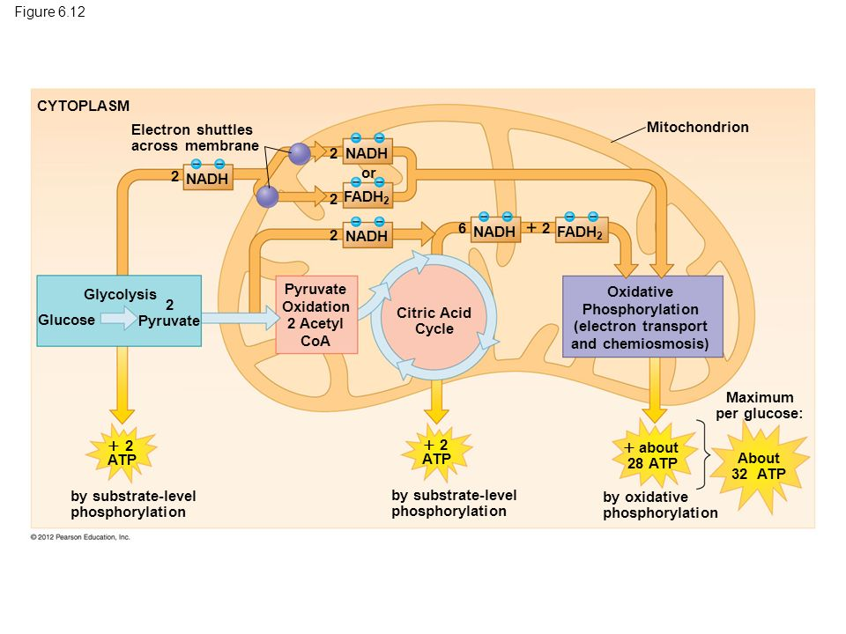

1. Skim chapter 9.2-9.4 (p.168-176) and write one-two sentences to describe the most important event(s) of:
   1. Glycolysis
   2. Oxidation of pyruvate
   3. Citric acid cycle
   4. Electron transport chain